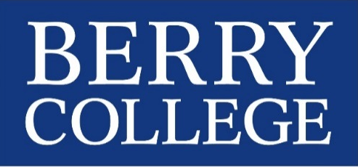
Berry College
Institutional Review Board
Continuing Review and Renewal Request

The federal government mandates that the IRB conduct continuing review of ongoing research not less than once per year (21CFR56.109 and 45CFR46109). Complete all questions and submit two signed originals to the IRB. Form must be typed.

Principal Investigator(s):Click here to enter text.
Campus Box/E-mail:Click here to enter text.

Faculty Supervisor (if applicable):Click here to enter text.
Campus Box/E-mail:Click here to enter text.

Project Title:Click here to enter text.

Protocol Number (from approval letter):Click here to enter text.

Date of latest approval:Click here to enter text.

Designation: Exempt Review Expedited Review Full Board Review
This study is ongoing or complete?
- If complete, please provide a short (one-page) summary with this form.
- If ongoing, complete all of the following questions.

- Participant Information
  - How many participants are in the study to this point?Click here to enter text.
  - Have there been any adverse reactions by any of the study participants? Yes No
If so, please describe the reaction(s) and how they were handled.
Click here to enter text.
  - Have any participants withdrawn from the project or complained about the study?
Yes No If yes, please explain.
Click here to enter text.
- Technical Issues
  - Have there been any revisions to the previously-approved protocol? Yes No
If yes, please explain.
Click here to enter text.
  - Have there been any changes to the research team? Yes No
If yes, please explain.
Click here to enter text.

- Informed Consent
  - Has written consent been obtained from all participants (or their legal guardian)? Yes No
If no, provide a copy of the original justification for waving consent.
  - If using written consent, have there been any changes to the approved consent form? Yes No
Attach a clean copy of your consent form.

- Certifications
I certify that the information provided for Continuing Review is accurate, no other procedures will be used in this research, and any modifications to this project of procedures described will be submitted to the IRB for approval prior to use with any subjects.

Signature of Investigator:_____________________________ Date: __________________________

Signature of Faculty Sponsor (if applicable):_________________________ Date:__________________

Submit two signed copies to: Berry College IRB, Campus Box 495006 (McAllister Hall, 219)

This review statement has been considered and Approved Not Approved
by the Berry College IRB.

__________________________________________ ______________________________
Chair, IRB Date

