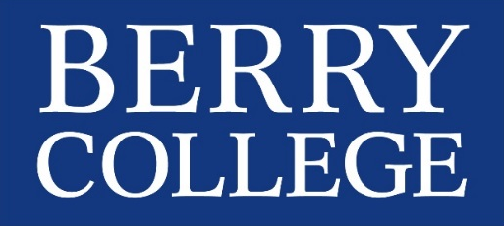
Office Use Only:
Funded: ☐Yes ☐No
Grant Number: __________________

2016 Richards Scholar Award
Application Form
Please hand deliver your signed application form to the Council on Student Scholarship,
McAllister 219 by March 27, 2017.
Student Information:
Name: Click here to enter text. Signature: _______________________________
ID Number: Click here to enter text.
Campus Mail Box: Click here to enter text.
Email address: Click here to enter text.
Major: Click here to enter text. GPA: Click here to enter text.
Number of hours by the end of Spring 2014: Click here to enter text.

Faculty Mentor Information:
Name: Click here to enter text. Signature: _________________________________
Department: Click here to enter text.
Campus Mail Box: Click here to enter text.
List of Campus Activities (including service/volunteer activities):
Click here to enter text.

Work positions held:
Click here to enter text.

Does the project require clearance (IRB or IACUC)?
Has it been obtained?
Yes, as a part of a larger faculty sponsor project
Yes, as my project
No clearance necessary
No, appropriate forms have been submitted
If no, when do you anticipate receiving clearance?Click here to enter text.

Have you applied for any other funding? If yes, please check which one you applied for below.
Richards Undergraduate Research Support Grant Kirbo Scholar Award
Synovus Scholar Award Student Research and Development Funds
Howell Grant (through the Career Center) Clark Grant (through the Career Center)

Essay:
Please attach an essay of no more than two typed, double-spaced pages, include reflections upon your first years at Berry, your academic and career goals, (your initial budget plans for using the $5,000 grant funds. You might consider summer research, travel to support research, an internship, attendance at an institute or workshop, etc.), and a timeline for your project.

Letters of Recommendation: Please provide three letters of recommendation [One from your academic advisor, one from your work supervisor, and a third from your mentor (if not academic advisor) or another faculty or staff member (if mentor and academic advisor are the same)].

Please hand deliver completed/signed application to
The Council on Student Scholarship, McAllister 219 by March 27, 2017.

