Guidelines and Instructions for the Symposium on Student Scholarship Abstracts
Undergraduate research is an inquiry or investigation conducted by an undergraduate student that makes an original intellectual or creative contribution to the discipline. The Berry College Annual Symposium on Student Scholarship was created to provide an opportunity for students to present their research findings and creative works. This day celebrates student scholarship and creative endeavors across all disciplines. All Berry students are welcome to submit an abstract and everyone is encouraged to attend the symposium!

Application Checklist Applicants must submit all of the following by the due date:

- Completed student application and abstract
- Cover page with signatures from the applicant, the applicant’s mentor, Department Chair, and School Dean

Printing Instructions: Please do not print double sided and do not staple.

By signing below, I agree that I have read and understand the above instructions and will follow them.

____________________________________________
Student Signature Date

By signing below, I agree that I have read the student’s application and abstract. This student’s work makes an original intellectual or creative contribution to the discipline. I fully support this application and recommend it for admission to the symposium.

____________________________________________
Mentor Signature Date

____________________________________________
Chair Signature Date

____________________________________________
Dean Signature Date

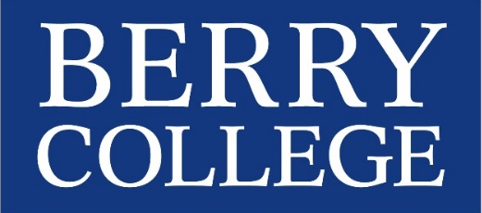
Office Use Only:
Submitted on time: ☐Yes ☐No
Emailed revisions? ☐
Session: ________________
Received electronic app? ☐

2018 SYMPOSIUM ON STUDENT SCHOLARSHIP
April 10, 2018
Student Submission Form
Deadline: 5:00 p.m. on March 5, 2018
NAME OF STUDENT(S) (as they should appear in the program)
Click here to enter text.

STUDENT CONTACT INFORMATION (for groups, choose a single point of contact)
Student Contact Name: Click here to enter text.
Campus Box: Click here to enter text.
Phone: Click here to enter text.
E-mail address: Click here to enter text.

NAME OF FACULTY MENTOR
Click here to enter text.

FACULTY MENTOR CONTACT INFORMATION
Department: Click here to enter text. Office Phone: Click here to enter text.
E-mail address: Click here to enter text.

TYPES OF PRESENTATION
ORAL PRESENTATION OPTIONS
Paper Presentation Pecha Kucha Performance (Music/Dance)

POSTER SESSION
Poster

If your abstract is not selected for an oral presentation, do you want to be considered for the poster session?
Yes No

EQUIPMENT NEEDED: Click here to enter text.
Note: For oral presentations, a computer and projection system will be provided.

ASSESSIBILITY SERVICES NEEDED
Sign Language Interpreter Accessibility Accommodations
Other: Click here to enter text.

PROJECT FUNDED BY:
Kirbo Scholars Program Richard Scholars Program George Scholars Fund
Synovus Program RUGS Other: Click here to enter text.

TITLE OF PRESENTATION (80 CHARACTERS INCLUDING SPACES)
Click here to enter text.

PLEASE PROVIDE AN ABSTRACT/DESCRIPTION OF THE PRESENTATION, PERFORMANCE, OR POSTER
(200 WORDS MAX)
Note: Accepted abstracts will be made available online. Students, faculty, and staff from all departments and disciplines will be in attendance.
Click here to enter text.

